**UTreatment**

**Risk management report**

**Document reference number:** UT-RMR

**Scope:** This document contains the risk management plan for UTreatment.

**Author:** Emma Rothmann, Katrine Stephansen, Louise Leonhard & Saaluja Sriharan

**References:**

**Revision history:**

| **Revision** | **Revised by** | **Revision date** | **Description of changes** |
| --- | --- | --- | --- |
| 1.0 | Emma Rothmann, Katrine Stephansen, Louise Leonhard and Saaluja Sriharan | 16.03.2022 | First version |
| 2.0 | Emma Rothmann and Saaluja Sriharan | 01.05.2022 | Second version |

**Overall plan for risk management**

The overall plan for risk management is based on figure 1 from the standard ISO 14971:2019 p. 8:

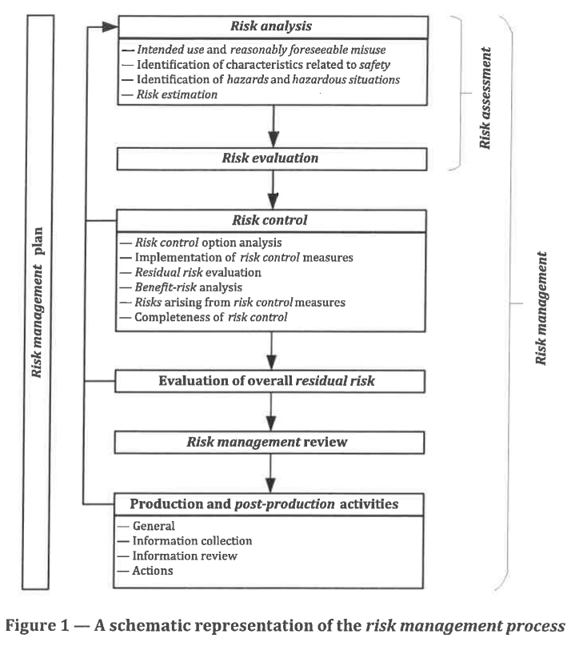

**Risk analysis**

Identification of hazards and hazardous situations through Fault Tree Analysis (FTA).

| **ID** | **Hazard** | **Cause of hazardous situation** | **Sequence of events** | **Hazardous situation** | **Harm** |
| --- | --- | --- | --- | --- | --- |
|  |  |  |  |  |  |

**Risk evaluation**

Quantification of severity:

| **Severity levels** | | **Failure description** | **Manufacturer’s definition** |
| --- | --- | --- | --- |
| **Description** | **Numeric value** |
| Catastrophic | 5 | Results in patient death | Death |
| Critical | 4 | Results in permanent impairment or life threatening injury | Irreversible nerve damage  Personal data breach |
| Serious | 3 | Results in injury or impairment requiring professional medical intervention | Reversible nerve damage  Skin burn |
| Minor | 2 | Results in temporary injury or impairment not requiring professional medical intervention | Worsening of symptoms or/and increased impact of quality of life |
| Negligible | 1 | Inconvenience or temporary discomfort | Skin irritation  Pain |

Probability of occurrence:

| **Probability category** | | **Description** |
| --- | --- | --- |
| **Description** | **Numeric value** |
| Frequent | 5 | Likely to occur immediately or within a short period (may happen several times in one year) |
| Probable | 4 | Probably to occur (may happen sometime in 1-2 years) |
| Occasional | 3 | Possible to occur (may happen sometime in 2-5 years) |
| Remote | 2 | Unlikely to occur (may happen sometime in 5-10 years) |
| Improbable | 1 | Improbable to occur (may happen sometime in 10-15 years) |

*Risk = Probability of occurrence x serverity*

Risk priority number (RPN) = 7

| **Probability of occurrence** | **Severity** | | | | |
| --- | --- | --- | --- | --- | --- |
| 1 | 2 | 3 | 4 | 5 |
| 5 | 5 | 10 | 15 | 20 | 25 |
| 4 | 4 | 8 | 12 | 16 | 20 |
| 3 | 3 | 6 | 9 | 12 | 15 |
| 2 | 2 | 4 | 6 | 8 | 10 |
| 1 | 1 | 2 | 3 | 4 | 5 |

**Risk control**

| **Risk evaluation** | **Risk control** | | |
| --- | --- | --- | --- |
| **Risk evaluation (acceptable / not acceptable)** | **Risk control option: Inherent safety by design** | **Risk control option: Protective measures** | **Risk control option: Information safety** |
|  |  |  |  |

**Evaluation of residual risk**

| **Risk control** | | | |
| --- | --- | --- | --- |
| **Risk control option: Information safety** | **Implementation of risk control measures (Ref to requirements and verifications)** | **Residual risk evaluation** | **Information to disclose in accompanying documents** |
|  |  |  |  |